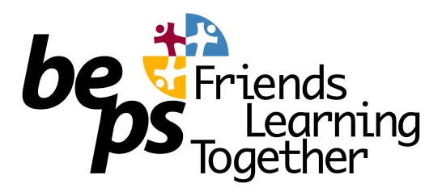
OSHC Service Philosophy
‘To provide quality care programs to primary-school-aged childcare at the Brunswick East Primary School Out of School Hours Care Service (BEPS OSHC) where we aim to provide a safe and stimulating environment in which children can play and relax before and after school and on pupil-free days. The service will provide inclusive child-centred programs underpinned by the learning frameworks, which focus on developmental, social and recreational activities and experiences appropriate to the needs of all the children.’
For Children:
- We value the rights, needs and interests of all children. Every child is special, every child is welcome.
- We embody a sense of belonging, operating as an ‘OSHC family’ – providing ownership, safety, warmth, shelter, food, friendship, respect and fun.
- We promote health and wellbeing, encourage the development of positive self-identity and self-esteem, taking responsibility for one’s own actions and guiding skill development with interpersonal relationships with others.
- We understand the importance of middle childhood and value the benefits of meaningful play and leisure, and provide collaborative, flexible child-centred programs where children have choice and become active participants in open-ended activities and experiences within a warm and welcoming atmosphere.
- We encourage respect for each other and the importance of developing equitable and respectful relationships, promoting inclusion and diversity within a non-biased and culturally competent environment. We promote the cultural safety of Aboriginal children and of children from culturally and/or linguistically diverse backgrounds. We promote the safety of children with a disability.
- Children are supported to become successful, competent and capable learners, we encourage children to have a voice.
- We have a commitment to child safety and the best interests of the child.

For Parents, Guardians and Families
- Collaboration is our guiding principle. We welcome, value and respect the opinions and wishes of all our parents, guardians and families. We encourage open communication and participation from all families.
- We aim to provide affordable and accessible quality care for all children and their parents, guardians and families in accordance with the Australian Government legislation and Regulations and the National Quality Standards for Outside School Hours Care.
- We respect the right to confidentiality and privacy.
- We keep families informed of industry changes and all relevant and up-to-date issues and practices through regular communication channels, such as one-on-one conversations (in person and on the telephone), email, the school newsletter and our website.

For Staff
- Our educators work collaboratively together as a diverse multi-skilled team, with relevant qualifications and experience, and guided by professional standards in practice, interactions and relationships with each other, children, families and the community.
- Our educators develop and maintain warm, responsive, equitable and respectful relationships with the children. Educators are sensitive to the individual needs and rights of all the children and their parents, guardians and families.
- Our educators aim to provide and maintain a safe, secure and protective environment at all times.
- Our educators value and maintain an interactive approach with children and their parents, guardians and families.
- Our educators are guided by the frameworks, in particular My Time, Our Place: Framework for School Age Care, in developing our unique pedagogy, to provide challenging activities and experiences for all children to promote their intellectual, social, emotional and cognitive development.
- Our educators are committed to critical reflective practice and continuous improvement.
- Our educators are committed to ongoing professional development as best practice and to enhance skills and knowledge.

For Community
- We undertake a holistic and collaborative approach, encouraging open communication and participation between all members of the school community.
- We seek wide community involvement and maintain supportive network and resource links within the community.
- We value and respect diversity and tolerance within an inclusive environment, acknowledging each other’s differences and similarities with acceptance and respect.
- We support and foster the schools values of fun, learning, friendliness, tolerance, respect, safety, trust and kindness.
- We promote respect for the environment, sustainability and respect for our natural resources.
- We value and respect Aboriginal and Torres Strait Islander cultures.

Sources:
Education & Care Services National Regulations (2011) – Regulation 55
National Quality Standard for Early Childhood Education and Care & School Age Care (2010) – Elements 1.1.1 3 1 3, 4 2 1, 5.1.1, 5.1.3, 6.1.1, 6.1.3, 6.2.1, 6.3.3, & 7.2.1.

